

LAB EXPERIMENT RECORD
SET 19

Department | Artificial Intelligence and Data Science
Course Code / Course Name | DSA0601 / Data Handling and Visualization
Name / Register Number | K.L DINESH ESHWAR / 192425027
Date / Day | 13/10/2026

Aim
To analyze survey responses analysis using the requested visualizations and dashboard views.

Dataset
Survey Responses Analysis
Survey_ID | Question_1 | Question_2 | Question_3
1 | A | B | C
2 | B | A | D
3 | C | A | B

R Data Setup
Run this setup once before the R programs below. The dataset is defined inline so each record can be copied and run without a separate CSV file.
R data setup
dat <- data.frame(
Survey_ID = c(1, 2, 3),
Question_1 = c("A", "B", "C"),
Question_2 = c("B", "A", "A"),
Question_3 = c("C", "D", "B")
)

PROGRAM 1: Question 1 Answer Distribution
Create a grouped bar chart showing the distribution of Question 1 answers.
R code
barplot(table(dat$Question_1), col="skyblue3", xlab="Answer", ylab="Responses", main="Question 1 Answer Counts")

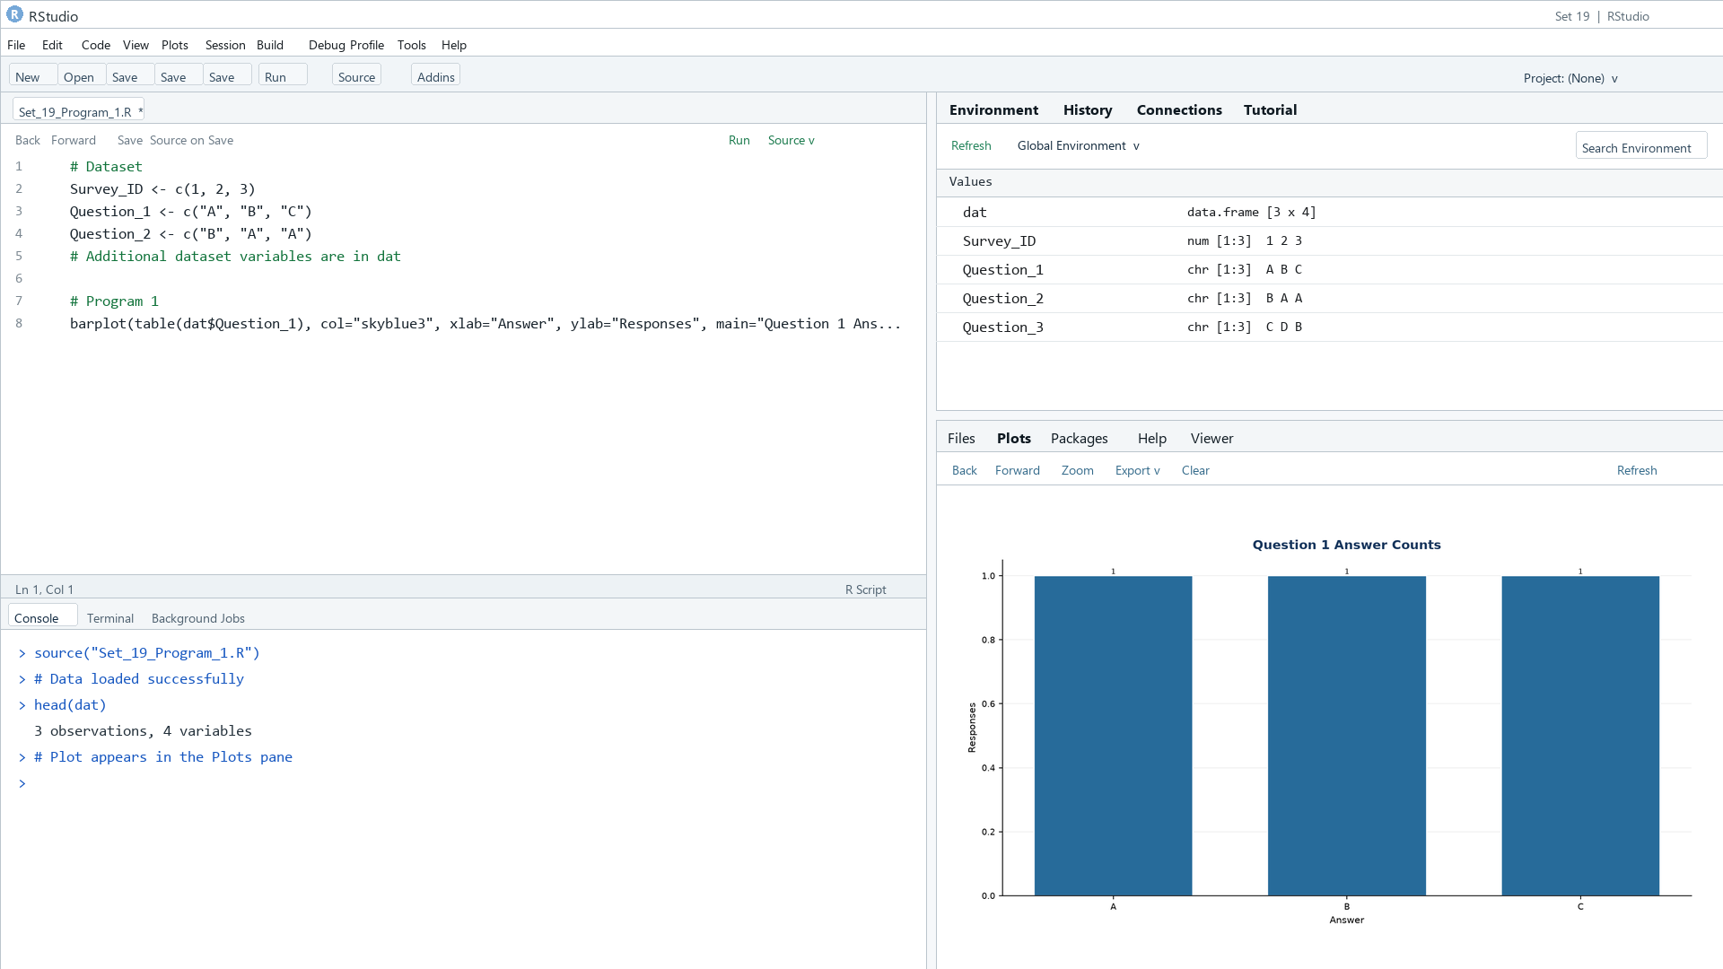
Output 1: Question 1 Answer Distribution
Observation: Answers A, B, and C each occur once.

PROGRAM 2: Stacked Responses Across Questions
Create a stacked bar chart of responses across all three questions.
R code
resp <- rbind(table(factor(dat$Question_1, levels=c("A","B","C","D"))), table(factor(dat$Question_2, levels=c("A","B","C","D"))), table(factor(dat$Question_3, levels=c("A","B","C","D"))))
barplot(t(resp), col=rainbow(4), legend=TRUE, xlab="Question", ylab="Responses", main="Answer Distribution Across Questions")

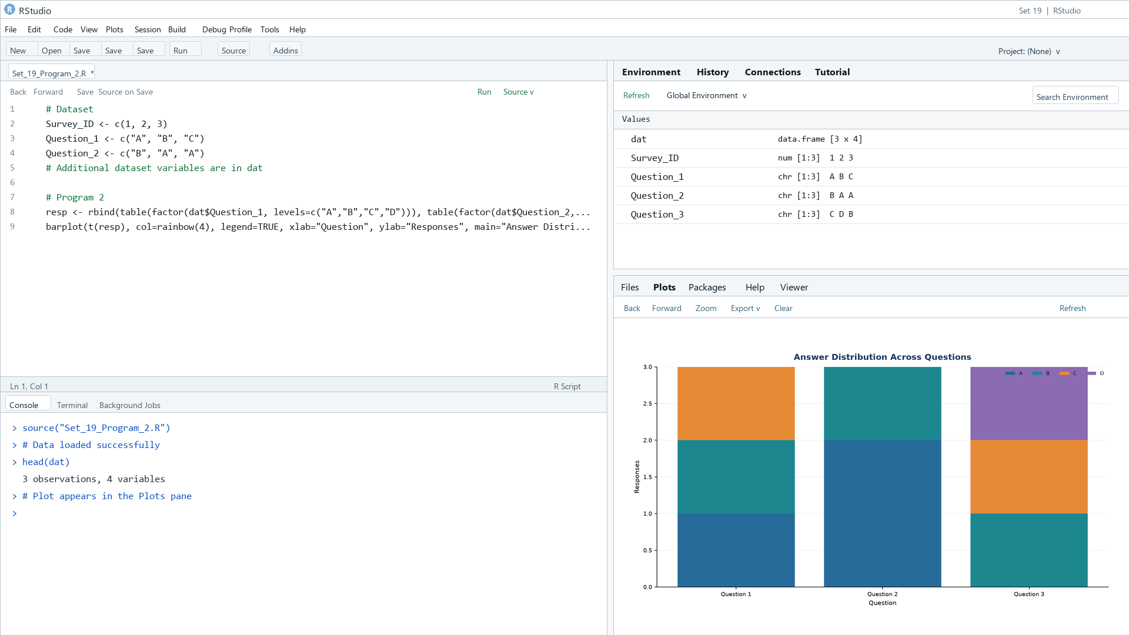

Output 2: Stacked Responses Across Questions

Observation: Question 2 has two A responses; Question 3 has one each of A, B, and D.

PROGRAM 3: Survey Response Table
Display the survey response data in a labeled table.
R code
print(dat)

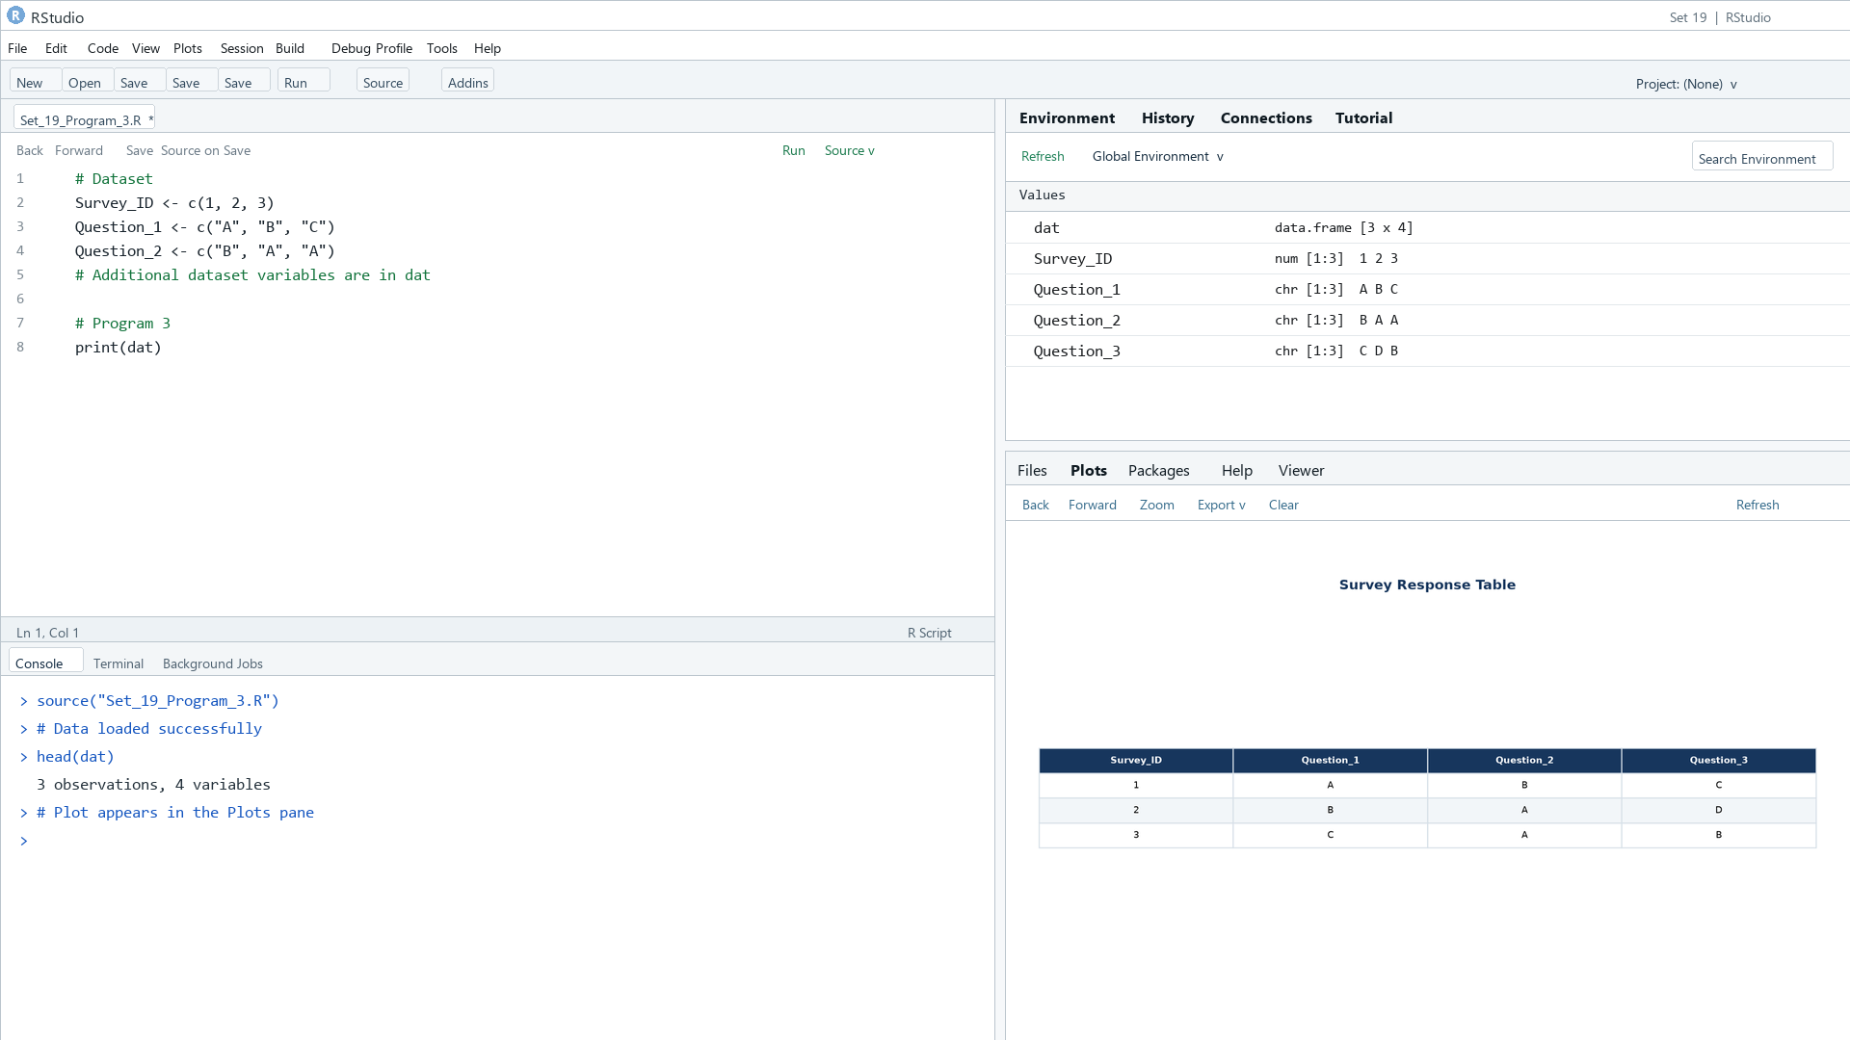

Output 3: Survey Response Table

Observation: The table displays all supplied survey responses.

PROGRAM 4: Survey Responses Dashboard
Create a Tableau dashboard combining the grouped and stacked bars with the survey response table.
Tableau build steps
Tableau dashboard build
1. Connect to the survey response data.
2. Create a Question_1 answer count chart.
3. Pivot the three question columns for the stacked response chart.
4. Add the original response table and place all views on a dashboard.

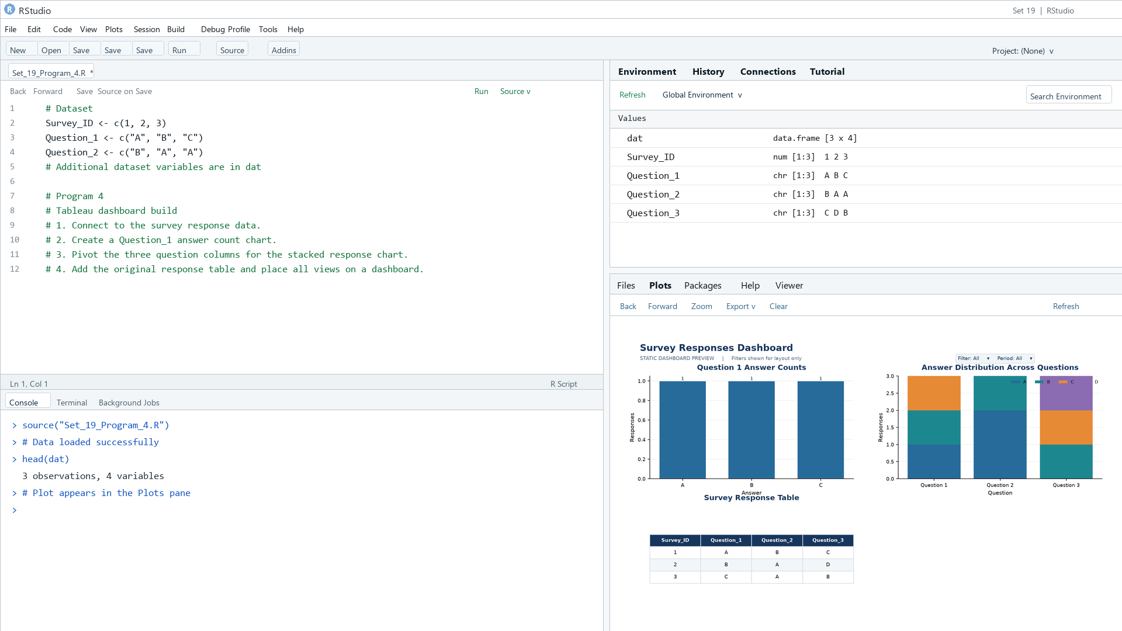
Output 4: Survey Responses Dashboard

Observation: The preview combines question-level distributions and respondent answers.

Procedure
1. Review the dataset table and confirm any illustrative fields noted in the record.
2. Run the R setup block once, then run the requested program code.
3. Compare the output screenshot with the observation and replace illustrative values when actual data is available.
4. For Tableau tasks, connect to the displayed data and follow the dashboard build steps.

Result
The requested charts and dashboard views for Set 19 were prepared from the displayed dataset. Outputs include labels, short observations, and code or dashboard construction steps.

Key Functions Used
plot(), barplot(), hist(), boxplot(), table().

